**Fitness Discounts – Option 1**

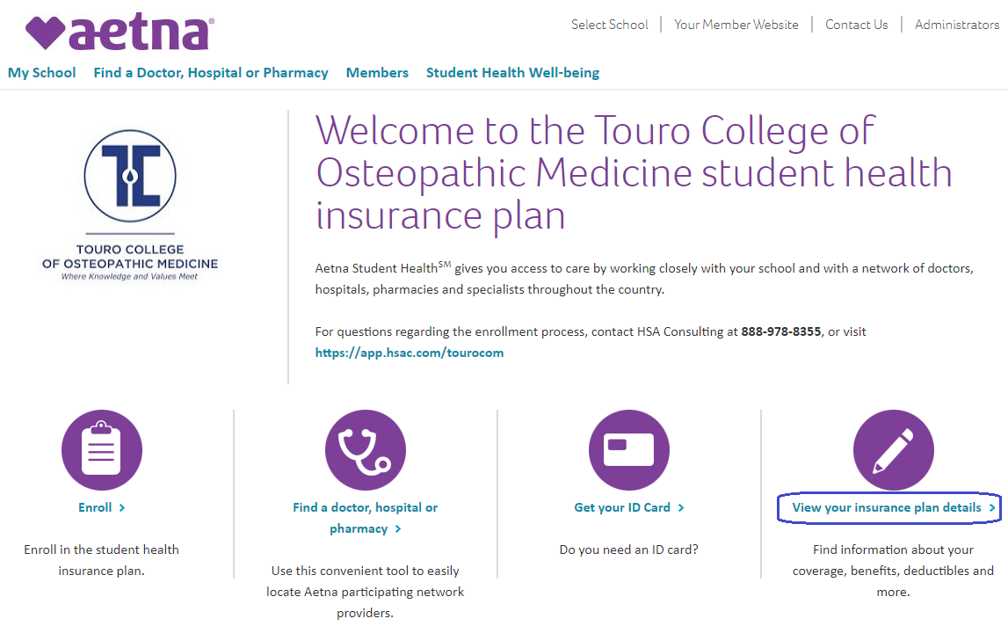

*From* [*www.aetnastudenthealth.com/tourocom*](http://www.aetnastudenthealth.com/tourocom)*, select “View Your Insurance Plan Details”, then “Health Programs”.*

*Scroll down to find “Fitness”, then select the link for globalfit.com/fitness.*

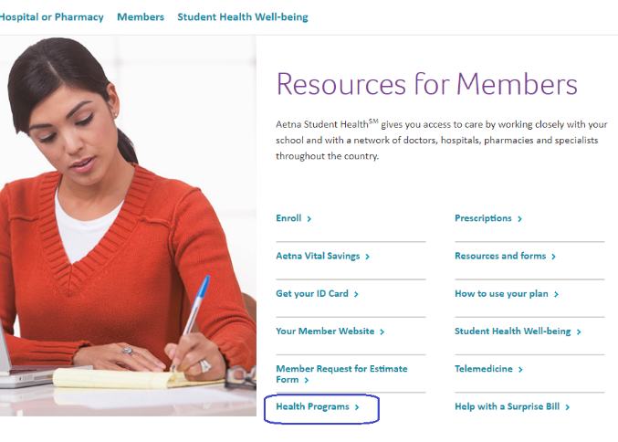

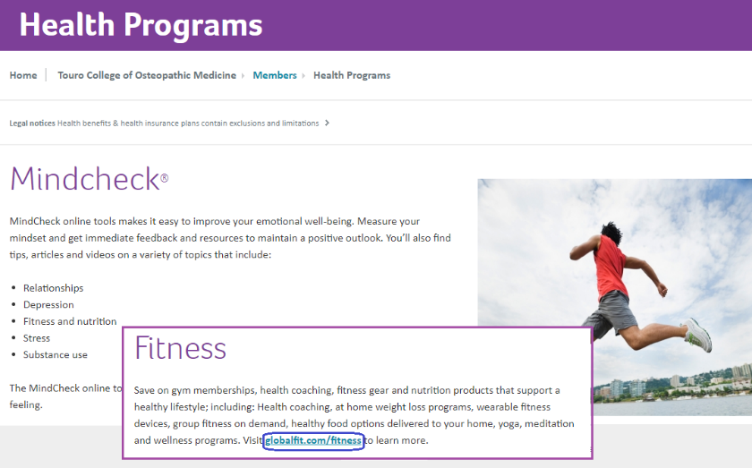



*You’ll be dropped to* [*https://marketplace.huskwellness.com/*](https://marketplace.huskwellness.com/)

*Select “Marketplace” then “LOGIN TO MARKETPLACE”, where you’ll be asked to create an Account.*





*You’ll be dropped to* [*https://marketplace.huskwellness.com/*](https://marketplace.huskwellness.com/)

*Select “Marketplace” then “LOGIN TO MARKETPLACE”, where you’ll be asked to create an Account.*

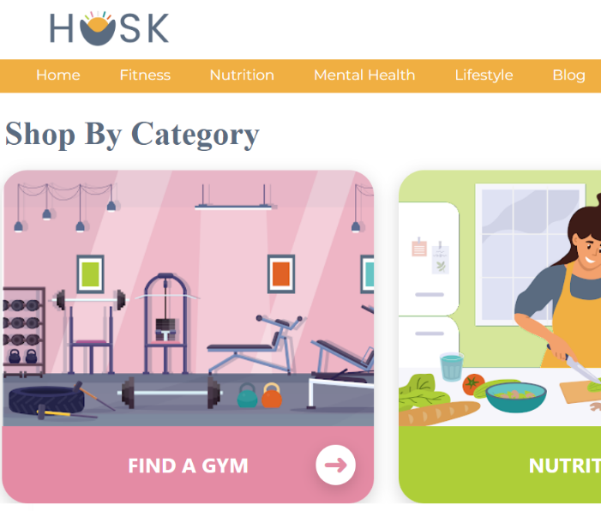

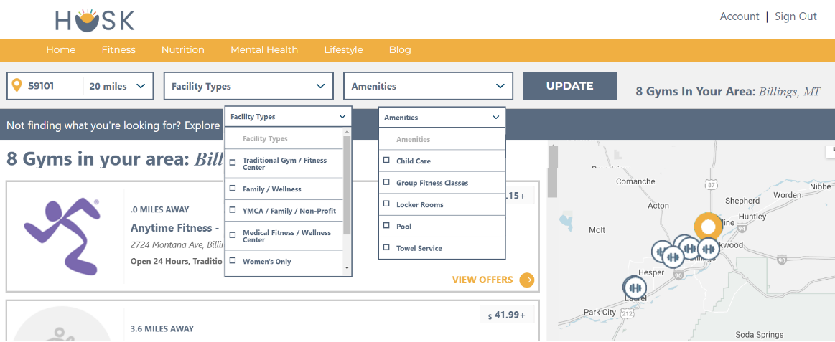

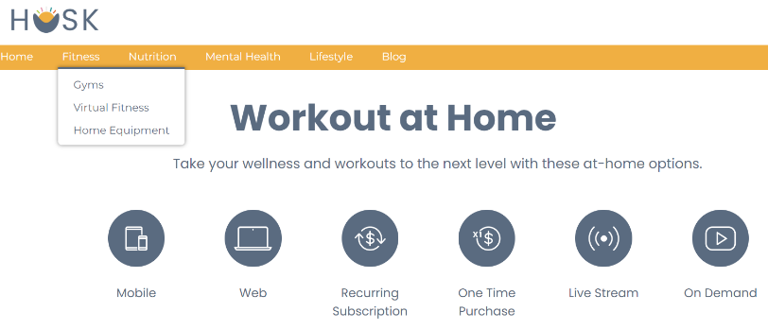

*By selecting “FIND A GYM”, you can search by zip code, and can set other filters.*

*In addition, you can search for virtual workouts.*

**Fitness Discounts – Option 2**

*This option is only for members who are enrolled in the Student Plan and have registered for their Aetna Member Website.*

